Solar Micro Grid

*A mini Project Report*

By

D.Sai Ram Chandu (N180866)



*Department of Electrical and Electronics Engineering.*

*Rajiv Gandhi University of Knowledge Technologies.*

*Nuzvid, India – 521202.*

*July 2023.*

Certificate

It is certified that the work contained in this mini project entitled ‘Solar Micro Grid’ by D Sai Ram Chandu (N180866) has been carried out under my supervision and that is has not been submitted elsewhere for a degree.

Project Guide

Mr. P Krishna

July 2023 Asst.Professor

RGUKT NUZVID

*Abstract*

Name Of the student: **D Sai Ram Chandu (N180866)**

Degree for Which Submitted: **B.Tech**

Term Project Title: **Solar Micro Grid** Department: **EEE**

Project Guide: **Mr. P Krishna**

Month and Year of thesis submission: **July 2023**

A solar microgrid is a localized and self-sufficient energy system that harnesses the power of solar energy to generate, distribute, and manage its own electricity. The concept of solar microgrids has gained significant attention in recent years as the demand for reliable and sustainable energy systems continues to grow. Solar microgrids offer numerous advantages, including a secure and stable energy supply, even during grid outages, as well as the potential to reduce greenhouse gas emissions and lower costs associated with energy production and distribution.

In contrast to traditional energy systems that rely on large central power plants and long-distance transmission, solar microgrids are designed to be decentralized. This means that electricity is generated and distributed locally, minimizing the vulnerabilities and inefficiencies associated with extensive transmission networks. By leveraging solar power, microgrids can tap into a clean and renewable energy source, thereby promoting sustainability and reducing reliance on fossil fuels. In This Research work focuses on the study of Micro grid for the Purpose of distributing energy in an efficiency way within a small range.

This project focuses on implementing a solar-powered microgrid specifically designed for an island area. The study examines the feasibility and effectiveness of deploying a localized energy system that relies on solar energy sources to meet the electricity needs of the island. By utilizing solar power within the microgrid, the project aims to enhance energy access, resilience, and sustainability in the island community.

*Acknowledgements*

It gives us immense pleasure and satisfaction in presenting the project report on “Solar Micro Grid” towards the partial fulfillment of Bachelor of Technology degree on Electrical and Electronics Engineering.

We wish to express our sincere gratitude to Mr. P Krishna for his kind guidance, valuable suggestions and timely advices. We would also like to thank each and every person who helped us in completion of this project directly or indirectly.

We would like to thank our parents and friends for their constant encouragement and help.

**Contents**

Certificate ii

Abstract iii

Acknowledgement iv

Contents v

List of Figures vii

Abbreviations viii

1. **Introduction** 
   1. Background ………………………………..……..……... 1
   2. Problem Statement ………………………………..…........ 3
   3. Objectives ……………………………………………....... 3

1.3.1 Overall objective …………………………………… 2

1.3.2 Specific objective ………………………………...... 2

* 1. Justification for the study ………………………………… 3

1. **Literature Survey**
   1. Outline of the Chapter …………………………………… 4
   2. Block Diagram of the Project ……………………………. 4
      1. PV Generation ……………………………………….. 5
      2. Need For MPPT Algorithm ……………..…………… 5
      3. MPPT Technique (The Perturb and Observe) ……….. 6
   3. Boost / Step Up converter (DC – DC) …………..……….. 6
   4. Bidirectional Converter …………………………………... 8
   5. Battery ……………………………………………………. 9
   6. Inverter …………………………………………………… 10
   7. LC Filter and Step Up transformer ………………………. 11
2. **Theoretical Framework** 
   1. Theoretical Analysis of Model ……………………..….. … 12
   2. Load Determination ………………………………………. 12
   3. PV Specification ………………………………………….. 13
   4. MPPT Algorithm …………………………………………. 13
   5. Boost Converter Design …………………………………... 14
   6. Battery Specifications …………………………………….. 15
3. **Implementation** 
   1. General Principle of Design …………………………………. 16
   2. Circuit Diagram ………………..…………………………….. 16

4.2.1 Implementing PV Array with Converter ………………. 18

4.2.2 Implementing Battery circuit …………………………... 21

4.2.3 Implementing Single Phase Inverter with an LC Filter ... 22

1. **Results and Discussions** 
   1. Result …………………………………………………............ 25
2. **Conclusions and Future Works 29**
3. **References** **30**

**List of Figures**

Fig 1 Block Diagram of Solar Microgrid ……………………………… 4

Fig 2 Internal Structure of PV ……………………………………......... 5

Fig 3 Block diagram of MPPT P & O Algorithm ……………………… 6

Fig 4 Boost Converter Circuit implementation ………………………… 7

Fig 5 Bi-Directional Converter Operations…………………………….. 8

Fig 6 Bi-Directional Converter Operations in Different Modes…………. 9

Fig 7 Single Phase Inverter………………………………...................... 10

Fig 8 LC Filter ………………………………............…………………. 11

Fig 9 Matlab Implementation of mode ………………………………… 17

Fig 10 PV array Parameters………………………………........................ 18

Fig 11 PV array Implementation ………………………………............... 18

Fig 12 PV Array Parameters…………………………………................. 19

Fig 13 Boost Converter with Mppt ………………………………............ 19

Fig 14 Battery Circuit Implementation ………………………………...... 21

Fig 15 Battery Controller Implementation ……………………………… 22

Fig 16 Single Phase inverter ………………………………...................... 23

Fig 17 LC filter and Linear Transformer Implementation ……………… 24

Fig 18 Second Order Response at 500 irradiance ………………………. 25

Fig 19 Bode plot for the given transfer function………………………… 26

Fig 20 Nyquist plot for the given transfer function……………………… 27

Fig 21 Root locus plot for the given transfer function…………………… 27

Fig 22 System Behavior for different irradiance………………………… 28

**Abbreviations**

PV – **P**hoto **V**oltaic

MPPT – **M**aximum **P**ower **P**oint **T**racking/**T**echnique

DC – **D**irect **C**urrent

AC – **A**lternative **C**urrent

P & O – **P**erturb and **O**bserve

SOC – **S**tate **O**f **C**harge

Chapter 1

**Introduction**

* 1. Background

In the current times, the scarcity of electricity has become a pressing issue due to the continuous increase in electricity consumers, surpassing the number of electricity producers. This imbalance in supply and demand leads to an energy deficit. To address this challenge, an effective solution is to generate our own energy and reduce dependence on external sources. By adopting a solar microgrid system, we can achieve energy self-sufficiency while promoting environmental friendliness.

A solar microgrid offers several advantages in overcoming energy scarcity. First and foremost, it enhances energy security. As the solar microgrid generates electricity locally, it reduces reliance on distant power plants and transmission networks, which are susceptible to disruptions. This ensures a more stable and reliable energy supply, even in the face of grid outages or other challenges.

Furthermore, a solar microgrid promotes environmental sustainability. By harnessing solar energy, a clean and renewable resource, the microgrid system significantly reduces greenhouse gas emissions. Solar power does not contribute to air pollution or climate change, making it an environmentally friendly alternative to traditional energy sources. The use of solar microgrids helps mitigate the harmful effects of fossil fuel-based energy generation, thus contributing to a greener and more sustainable future.

* 1. Problem Statement

The maintaining of the conventional power grid is becoming more and more complex as it is inter connection among all regional grids together .The problem occurred at one region may influence in some other region. With the De centralizing the power distribution to micro grids in respective regions, the generation and distribution becomes much simpler and easier. The fault clearing ways will also become simple as it constrained to particular region of distribution. The main generating sources of microgrids are assumed to use renewable & non-conventional sources of electricity generation .In keeping the thought of unavailability of conventional sources of electricity generation as the main fuel for maintaining them may exhaust in few years from now.

The major reason for encouraging microgrids is the same problem of above. In keeping all of the above positives with microgrids we study helps to promote future energy demands and makes distribution easy.

* 1. Objectives

The main objective of the project is to develop a Solar Micro grid on an isolated Area. The project has a main objective whose achievement is aided by breaking it further down into other smaller specific objectives.

* + 1. Overall objective

The main objective of the project is to develop a solar microgrid on an isolated area.

* + 1. Specific Objectives

The project will be divided into the following specific objectives that will aid in achieving

The main objective

1. Design a PV and Converter.
2. Design a battery charging circuit.
3. Design Inverter and a filter for getting perfect output.
4. Step up the Inverter Output.
   1. Justification for the study

The need for individual solar power grid has over the years increased. Currently a lot of research is being conducted in order to obtain suitable methods that can be used in the development of such grids. The following are reasons why it is important

1. Improved reliability: Microgrids are designed to operate in both grid-connected and isolated modes, allowing them to provide a more resilient and reliable source of power, particularly during outages and other disruptions.
2. Increased energy security: By generating and managing their own energy, microgrids can reduce dependence on the centralized grid, thereby increasing energy security.
3. Better integration of renewables: Microgrids are optimized for the integration of renewable energy sources, such as solar and wind, allowing for better utilization of these resources.
4. Reduced transmission losses: By generating energy closer to the point of use, microgrids can reduce transmission losses and increase efficiency.
   * 1. Scope of work

This project entails the design and implementation of an individual solar grid, examining existing methods and seeking improvements where performance is lacking. The primary objective is to store solar energy from photovoltaic (PV) systems efficiently, utilizing batteries for storage. Additionally, the project aims to optimize the conversion of stored energy for everyday use, ensuring cost-effectiveness. By addressing current limitations, such as low performance and inadequate energy storage, the study intends to develop enhanced solutions that enable efficient utilization of solar power, leading to greater sustainability and affordability for end-users.

Chapter 2

Literature Survey

* 1. Outline of the Chapter

This chapter presents a detailed analysis of a localized solar-powered microgrid. It explores the key components and provides a theoretical framework for the overall project.

* 1. Block Diagram of the Project

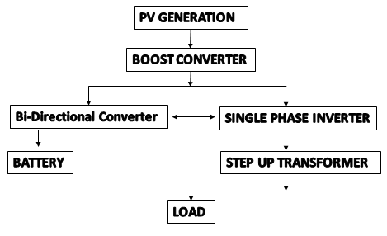

*Fig 1. Block Diagram of Solar Microgrid.*

* + 1. PV Generation

Photovoltaic (PV) generation is a process that converts sunlight into electricity. It works by utilizing photovoltaic cells, which are made of semiconducting materials such as silicon. When sunlight is absorbed by these cells, it excites the electrons in the material, causing them to flow and generate a flow of direct current (DC) electricity. The PV cells are arranged in panels, which can then be connected together to form a PV array. The size of the array can vary, depending on the amount of electricity needed to power homes, businesses, or communities.

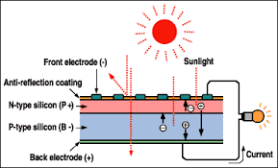

*Fig 2. Internal Structure of PV*

* + 1. Need For MPPT Algorithm?

MPPT (Maximum Power Point Tracking) algorithm is an essential component in microgrid systems as it optimizes the power output of photovoltaic (PV) panels. The algorithm tracks the point at which the PV panel generates maximum power and adjusts the operating point accordingly. Without MPPT, the power output of the PV panel would be lower, leading to decreased energy efficiency and reduced system performance. MPPT algorithms increase the overall efficiency of microgrid systems by ensuring that the maximum power is extracted from the PV panels, which ultimately results in a more reliable and cost-effective power generation system.

* + 1. MPPT Technique(The Perturb and Observe)

The Perturb and Observe (P&O) method is a type of MPPT algorithm. It involves periodically perturbing the operating voltage or current of the solar panels and observing the change in power output, using this information to adjust the operating point to the maximum power point. The P&O method is simple to implement, but its efficiency can be improved by using more advanced MPPT techniques.



*Fig 3. Block Diagram of MPPT P&O Algorithm*

* 1. Boost / Step Up converter ( DC – DC )

Drawback of step-down/buck dc-dc converter is that when converter switch is on it transfer power from input to output but when converter switch is off zero output value across p-v module is obtain which gives the point of operation stay near the open circuit voltage which provide losses.

Boost converter gives a dc output voltage which is more than the applied dc input voltage, filter which consisting of inductor and capacitor, is utilized to decrease ripple in dc output voltage and dc output current respectively and is connected at output terminal of the converter. The operating principle step-up/boost converter consists two different states of operation.

* When switch is on that is switch is close, result an increase in current.
* When switch is off that is open, result in reducing in inductor current.

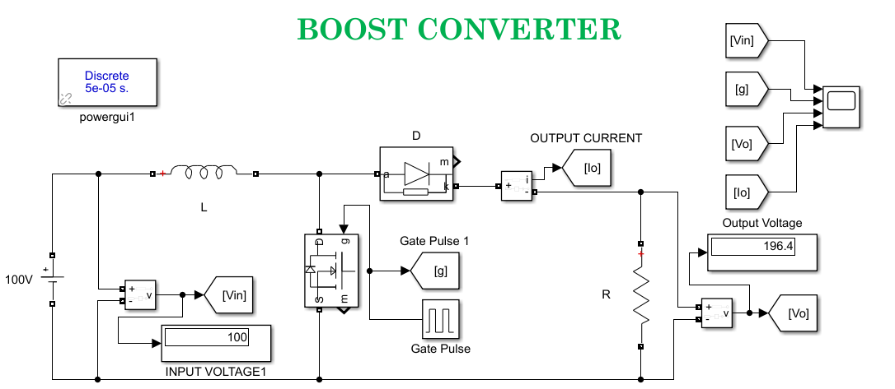

*Fig 4. Boost converter circuit implementation*

The PV output is connected to the Boost Converter Because a Boost Converter is a type of DC-DC power converter that increases the voltage of a direct current (DC) input to a higher value. It operates by storing energy in an inductor during the input voltage's high phase and releasing it to the output stage during the low phase of the input voltage. This results in a higher output voltage than the input voltage.

Basically we use Boost Converter to regulate the output voltage from solar panels to match the voltage requirements of battery.

Output V­o =

By varying duty cycle we can vary the output most in cases duty cycle value is ≤ 0.5.

After stepping up the voltage, we need to store the energy in a battery or a super capacitor in order to achieve good efficiency. We cannot directly store the energy received from the boost converter to the battery because the boost converter output is dependent on the PV array output, which is dependent on the climate. We can estimate the climate, but we cannot get the exact output, sometimes it may or may not, so the boost converter cannot give an exact matching output for the battery to charge or store. If we store the exact output from the boost converter to the battery, sometimes the voltage will be too high and sometimes too low, which may cause battery drain or other problems. Therefore, we need another converter here to charge the battery, which can do both buck and boost operations simultaneously to avoid problems with the battery.

* 1. Bidirectional Converter ( DC – DC )

A Bidirectional Converter is a type of DC-DC power converter that can handle power flow in both directions, allowing energy to be either drawn from a source or delivered to a load. It can transfer power from one voltage source to another with a different voltage level, and it can also store energy in a storage device, such as a battery or a capacitor, during periods of excess energy generation, and release it when needed.

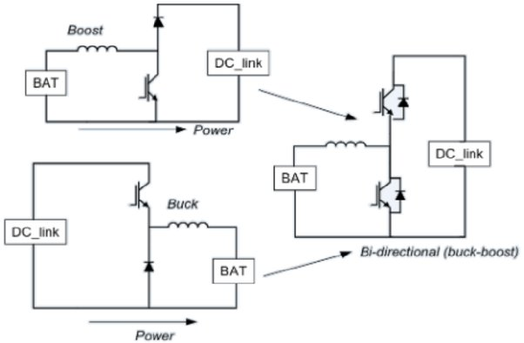

*Fig 5. Bi-Directional Converter Operations.*

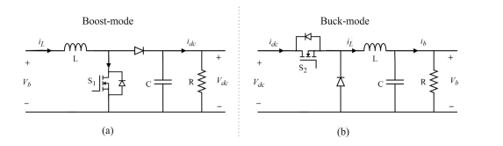

*Fig 6. Bi-Directional Converter Operation in Different Modes.*

* 1. Battery

Why do we need to store energy? We can directly use the PV energy generation to power the load using a converter and inverter, but why do we really have to store the energy? Because Energy generated by PV systems can vary greatly depending on weather conditions and the time of day. By storing excess energy generated during periods of high energy generation, it can be used later when energy generation is low, helping to balance energy generation and demand. By storing energy, PV systems can provide a continuous power supply, even when the sun is not shining. This makes them ideal for off-grid applications, such as remote homes or emergency power systems. By storing excess energy generated by PV systems, it can be used later when energy generation is low, instead of being fed back into the grid. This helps to maximize energy efficiency and reduce energy waste.

In our project, we are going to use a lithium-ion battery, as these lithium batteries are now popular and are used everywhere. We are going to store the power generated by the PV to a battery according to our needs. The bidirectional converter does a better job than any other converter to keep and improve battery cycles during charging. The converter is mostly controlled by a PWA so that we can have control over the efficiency. We can also use a supercapacitor power bank to keep a constant voltage, so that a big bank of capacitors can also be used as temporary storage, as capacitors don't last as long as batteries, but it may increase power efficiency.

* 1. Inverter

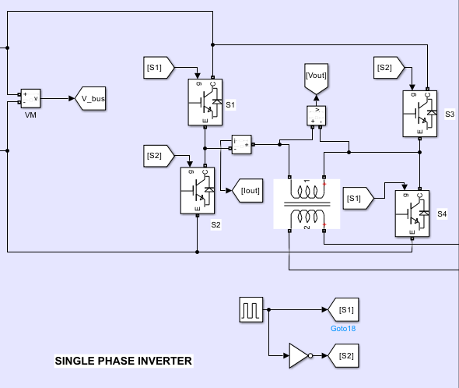In a microgrid, an inverter is a crucial component that plays a vital role in converting DC power generated by the renewable energy sources (e.g. solar panels, wind turbines) into AC power that can be utilized by the electrical loads and fed back into the grid. The inverter also helps regulate the voltage and frequency of the AC power, ensuring that it is within the required specifications for safe and reliable operation of the electrical loads and the grid. In this report we use single phase inverter for simple Dc to Ac conversion

*Fig 7. Single Phase Inverter*

The working principle of single phase full bridge inverter is based on the sequential triggering of IGBT’s placed diagonally opposite. This means, for half of time period, T3 & T4 will be triggered while for the remaining half of time period, T1 & T2 will be triggered. Only two IGBT’S are turned ON in half of the time period.

Carefully observe the waveform of the gating signal. You will notice that T1 & T2 are triggered simultaneously for a time T/2.

Therefore, load is connected to source through T1 & T2 and hence, the load voltage is equal to the source voltage with positive polarity. This is the reason; the load voltage is shown positive & equal to Vs in the output voltage waveform.

As soon as the gate signal (ig1 & ig2) are removed, T1 and T2 gest turned OFF. However, at the same instant gate signal (ig3 & ig4) are applied and hence, T3 & T4 are turned ON. When T3 & T4 are conducting, load gets connected to the source. The load voltage magnitude is again Vs but with reverse polarity. This is the reason, the output voltage is shown negative in the voltage waveform.

* 1. LC Filter and Step Up transformer.

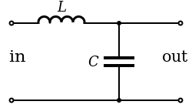

*Fig 8. LC Filter*

An LC filter is connected to an inverter to remove unwanted harmonics and obtain a clean sine wave output. The filter consists of an inductor and capacitor that work together to block high-frequency signals and allow the fundamental frequency to pass through. The filtered output is then sent to a step-up transformer to match the desired voltage level. The LC filter improves power quality and reduces distortions, ensuring a smoother and more stable power output from the inverter.

Chapter 3

Theoretical Framework

* 1. Theoretical Analysis of Model

In the above chapters, we learned about the different types of elements in a microgrid. Now, In This chapter our main focus on calculating various parameters for the solar-based microgrid model, enabling us to design an appropriate system for our needs.

* 1. Load Determination

In our project, the first step is to determine the appropriate load. This is crucial as it helps us understand the amount of demand we need to fulfill. Once we have this information, we can proceed with calculating the remaining requirements for the system.

Most of the common loads are being used

First, we use four lights which consume 20 watts each, three fans which consume 60 watts each, and one TV which consumes 120 watts and one refrigerator which consumes 500 watts.

Total Power usage = 4x(lights wattage)+3x(fans wattages)+1x(TV wattage)+1x(refrigerator).

Total Power Usage is 880 watts.

* 1. PV Specifications

Load Power Usage = 880watts

How many hours we need the back up 12 hrs.

Load Power X No. of hrs.

880 X 12 = 10560 Whr

Average Period of Sunshine = 6 hrs.

Total Back up / Avg period of sunshine

10560 / 6 = 1,760

Therefore the PV specification is to have 1.76 Kw.It is better to have a 2Kw solar panel.

PV array depends up on the irradiation and the temperature so the inputs. Output of the PV is Dc.

Then the PV Voltage is boosted with the Boost Converter and the duty ratio is designed by MPPT algorithm as Follows

* 1. MPPT Algorithm

The MPPT (Maximum Power Point Tracking) perturb and observe algorithm is a popular method used in photovoltaic systems to track and maximize the power output from a solar panel. Here's an explanation of how the perturb and observe algorithm works:

* Measure the current voltage (V) and current (I) from the solar panel.
* Initialize the duty cycle (D) of the DC-DC converter to a certain value.
* Calculate the power output (P = V * I).
* Perturb the duty cycle by a small increment (ΔD) in either the positive or negative direction.
* Measure the new voltage and current with the perturbed duty cycle.
* Calculate the new power output.
* Compare the new power output with the previous power output.
* If the new power output is greater than the previous power output, continue perturbing in the same direction.
* If the new power output is lower than the previous power output, change the direction of perturbation (if previously positive, make it negative, and vice versa).
* Repeat steps 5-9 until the power output starts decreasing.
* Once the power output starts decreasing, move back to the previous duty cycle (before the decrease) and that becomes the maximum power point.
* This maximum power point is maintained by continuously perturbing the duty cycle around it to track any changes in solar conditions.

The Perturb and observe algorithm operates by perturbing the duty cycle of the DC-DC converter and observing the resulting change in power output. It adjusts the duty cycle in the direction that leads to an increase in power until the power output starts to decrease. This ensures that the system is operating at or near the maximum power point of the solar panel.

The algorithm dynamically adjusts the duty cycle to account for changes in solar irradiance and temperature, continuously seeking the maximum power point. It allows the PV system to efficiently extract the maximum available power from the solar panel, thereby optimizing the energy generation.

* 1. Boost Converter Design

Input Voltage $V_{in}=29 V$

Output Voltage $V_{out}=48 V$

Switching frequency $f_{sw}=5 Khz$

Rated Power $=2131.5 W$

Current Ripple $I_{∆}=5 \%$

Voltage Ripple $V_{∆}=1\%$

Input Current $\frac{Rated Power}{V_{in}}=\frac{2131.5}{29}=73.5 A$

Current Ripple $I_{∆}=5 \% of 73.5 A=3.675A$

Voltage Ripple $V_{∆}=1\% of 48 V=0.48 V$

Output Current $\frac{Rated Power}{V_{out}}=\frac{2131.5}{48}=44.40 A$

Inductance L = $\frac{V_{in}(V_{out}-V_{in)}}{f_{sw}*I_{∆}*V_{out}}=\frac{29(48-29)}{5000 x 3.675 x 48}=6.247165533 x {10}^{-4}H$

Capacitance C = $\frac{I_{out}(V_{out}-V_{in)}}{f_{sw}*V_{∆}*V_{out}}=\frac{44.40(48-29)}{5000*0.48*48}=7.322916667x {10}^{-3}F$

Therefore, we have established theoretical parameters for the Boost converter. The pulse of the converter is determined by the MPPT algorithm.

* 1. Battery Specifications

Battery capacity is given as

C = (P x T) / (V x η x K)

Where C = Battery capacity

P = Load Power in Watts

T = Back up Time

V = Unit Voltage

η = Battery Inverter Efficiency

K = Battery Discharge Coefficient

When T < 3 hrs. K = 0.6

T = 3 ~ 5hrs K = 0.8

T = 5 ~ 10hrs K = 0.85

T = >10hrs K = 1

C = (880*12)/ (48*0.92*1) = 239.13Ah

To achieve the required battery specifications of 240 Ah and 48 volts, we can employ various battery configurations, such as series and parallel connections, combining different batteries.

Chapter 4

Implementation

* 1. General Principle of Design

In this chapter, we will transition from the theoretical framework discussed in the previous chapter to the practical implementation of the solar microgrid model using the MATLAB software. The implementation process will be divided into several distinct sections.

* Implementing PV Array with Converter.
* Implementing Battery circuit.
* Developing Inverter and Filter Circuit.
  1. Circuit Diagram

The figure illustrates the specific electronic designs and showcases the comprehensive functioning of the solar microgrid.

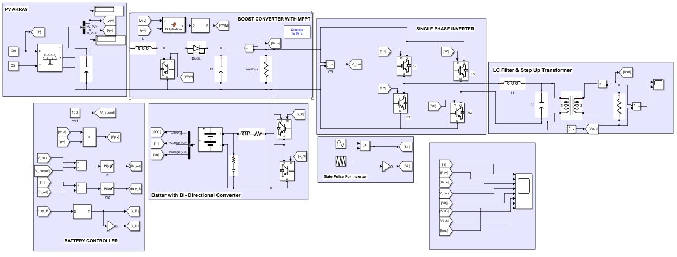*fig 9 . Matlab Implementation of model.*

* + 1. Implementing PV Array with Converter

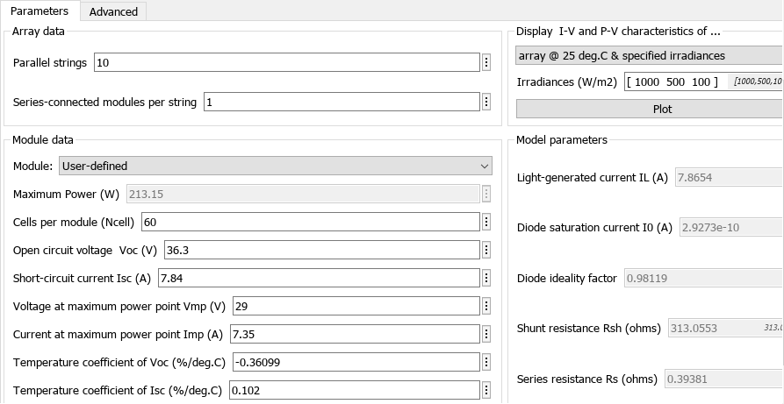The solar array's inputs consist of irradiation and temperature, which significantly influence its outputs. Consequently, the PV array's voltage and power vary for different levels of irradiance. By examining the figure, we can observe various parameters such as maximum power point voltage, open circuit voltage, and short circuit voltage.

*Fig 10. PV array Parameters.*

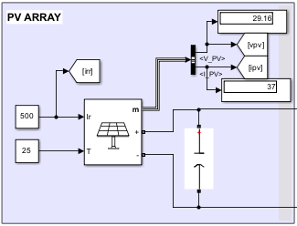

*Fig 11. PV array Implementation.*

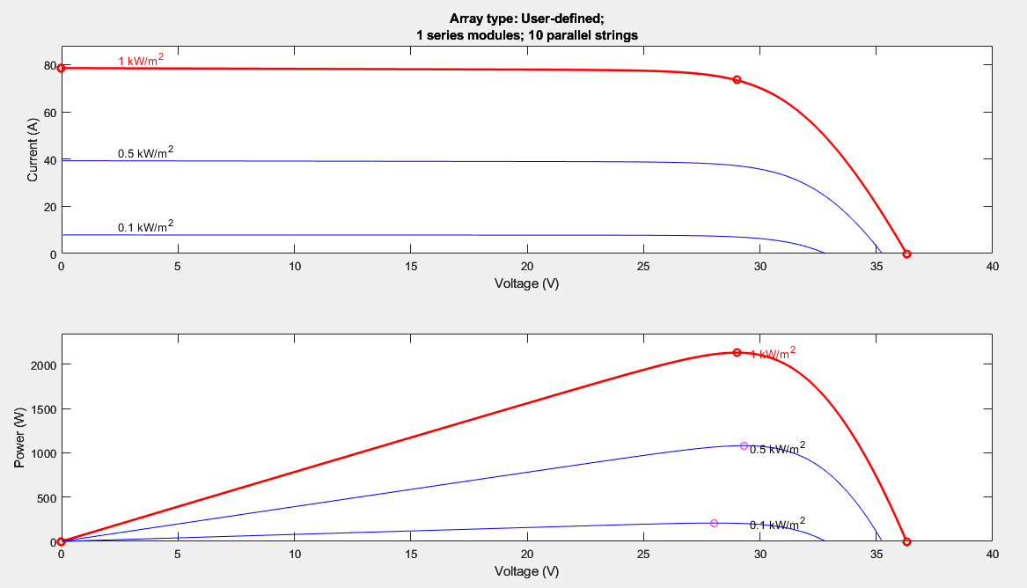

*Fig 12. PV array Parameters.*

The above figure demonstrates the behavior of the photovoltaic (PV) system in response to changes in irradiance. We can observe that the maximum power output is 2131.5 Watts at a voltage of 29 volts. The PV array is linked to a capacitor, which serves to stabilize the voltage and is commonly connected to a boost converter.

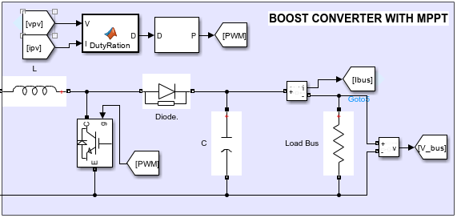

*Fig 13. Boost Converter with Mppt*

The inductance and capacitance values for the converter have been calculated in the previous chapter. Now, let's input these values into MATLAB. The MATLAB function includes the MPPT algorithm, which is derived from the earlier chapters. Below is the code, and it is evident that the algorithm is built upon the concepts discussed previously.

Perturb and Observe MPPT Algorithm.

function D =DutyRation(V, I)

Dmax = 0.95;

Dmin=0;

Dinit=0.95;

deltaD=0.0001;

persistent Vold Pold Dold;

dataType = 'double';

if isempty(Vold)

Vold=0;

Pold=0;

Dold=Dinit;

end

P=V*I;

dV=V-Vold;

dP=P-Pold;

if dP ~= 0

if dP<0

if dV<0

D = Dold-deltaD;

else

D = Dold + deltaD;

end

else

if dV<0

D= Dold + deltaD;

else

D= Dold - deltaD;

end

end

else D=Dold;

end

if D>= Dmax || D <= Dmin

D=Dold;

end

Dold=D;

Vold=V;

Pold=P;

* + 1. Implementing Battery circuit

The role of the battery in the system is to provide power when there is no PV generation and to charge whenever the PV generation is high. The battery is characterized by parameters such as voltage, current, and state of charge. In this case, we are utilizing a 48-volt battery with a rating of 240 ampere-hours. The charging and discharging of the battery are controlled by a bi-directional converter.

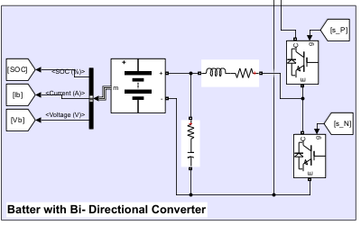

*Fig 14. Battery Circuit Implementation.*

Battery Controller

A bidirectional converter is used to stabilize and store the voltage in the battery and get power from the battery to load. To achieve good efficiency, a battery controller is needed to control the bidirectional converter mode, such as buck or boost mode, as discussed in the previous chapter. First, we take a reference voltage of 100 and the voltage from the boost converter. We use a PI controller to regulate and maintain the desired output. PI stands for Proportional Integral, which refers to two components of the control algorithm. The proportional component uses the error between the desired output and the current output to produce a control signal. The integral component takes into account the accumulated error over time and adds it to the control signal to produce a more precise adjustment. This combination of proportional and integral control results in a more stable and accurate output. Again, we use a PI controller to stabilize the battery current. The resultant pulse is then given to the Pulse Width Modulation (PWM) block, so we can 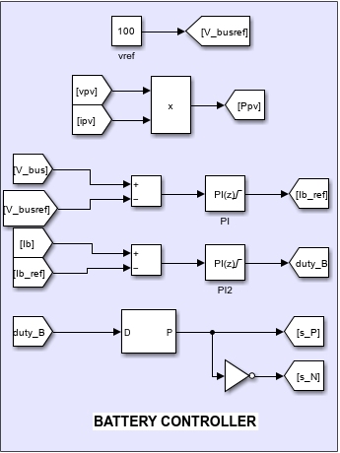generate a duty cycle for the bidirectional converter.

*Fig 15. Battery Controller Implementation.*

* + 1. Implementing Single Phase Inverter with an LC filter.

A single-phase inverter is an electronic device that converts DC (direct current) power into AC (alternating current) power in single-phase electrical systems. Its primary purpose is to facilitate the connection of renewable energy sources, such as solar panels or batteries, to the utility grid or to power household appliances.

The working principle of a single-phase inverter involves several stages. First, the DC power source, such as a solar panel, is fed into the inverter. The inverter then converts the DC power into a high-frequency AC waveform. This AC waveform is then processed to generate a sinusoidal AC output, which matches the utility grid frequency.

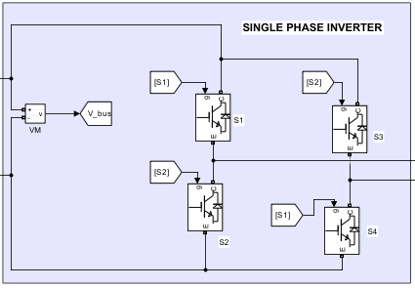

*Fig 16. Single Phase inverter*

The single-phase full bridge inverter comprises four sequential switches, which are controlled by a PWM (Pulse Width Modulation) signal. The PWM signal is generated by comparing a sinusoidal wave with a 20 kHz signal, and the resulting pulse is applied to the switches.

LC Filter Design

Input Voltage $V_{in}=53 V$.

Output Power P = $2135.5 W$.

Current I = $\frac{2135.5}{53}=40.29 A$.

Switching-Frequency $f_{sw}=20 kHz$.

Current Ripple $I_{∆}=20\% of Rated current (40.29)=8A$.

${∆I}_{L(max)}$ = $\frac{V_{dc}}{4*L*f_{sw}}$.

Inductance L = $\frac{53√2}{4*8\sqrt{2}*20000}=0.0828 mH$.

Now $F_{c}=\frac{1}{2π\sqrt{Lc}}$.

$F_{c}=\frac{F_{sw}}{10}$.

Capacitance C = ${[\frac{I_{out(rms)}}{2πF_{sw}}]}^{2}x \frac{1}{L}={[\frac{40.29}{2π*20000}]}^{2}x \frac{1}{0.0828mH}=1.24 mF$.

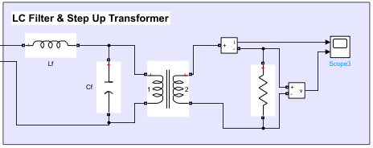

*Fig 17. LC filter and Linear Transformer Implementation*

The inductor and capacitor values are determined based on the system requirements and fed into MATLAB. Additionally, a step-up transformer is employed to elevate the voltage from the filter. The transformer then further steps up the voltage to 230 volts, with a fundamental frequency of 50Hz, before supplying it to the load.

Chapter 5

Results and Discussions

5.1 Result

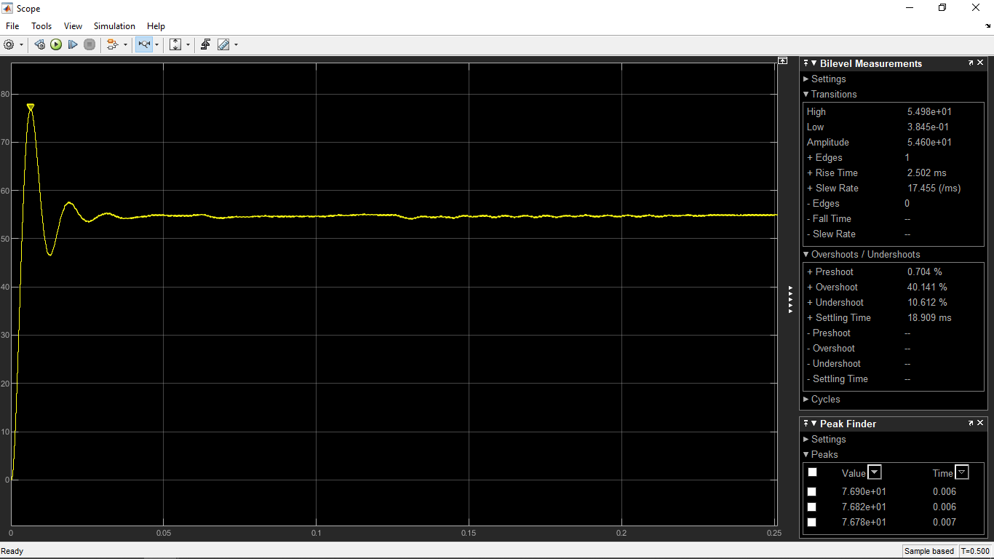Following a thorough analysis and careful observation of the solar-based microgrid, a second-order transfer function has been derived based on the solar output. The derived transfer function is presented below.

*Fig 18. Second Order Response at 500 Irradiance*

Overshoot = 40.131 %

$$\% Overshoot=e\frac{-πζ}{\sqrt{1-ζ^{2}}}=0.4013$$

$$==>\frac{-πζ}{\sqrt{1-ζ^{2}}}=\ln\left(0.4013\right) ==>\frac{-πζ}{\sqrt{1-ζ^{2}}}=-0.912$$

$$==>\frac{ζ}{\sqrt{1-ζ^{2}}}=\frac{0.912}{3.14}=0.29 ==> \frac{\sqrt{1-ζ^{2}}}{ζ}=\frac{1}{0.29}$$

$$Wkt Tanθ= \frac{\sqrt{1-ζ^{2}}}{ζ}=> θ={Tan}^{-1}\left(\frac{1}{0.29}\right)=73.82.$$

$$ζ=Cosθ=Cos \left(73.82\right)=0.27 So it is Underdamped.$$

Damped ratio = 0.27.

We know that

Settling time = 19.424 ms

Peak time = 0.006

$$t_{p}=\frac{π}{ω_{d}}= ω_{d }= \frac{π}{0.006}=\frac{3.14}{0.006}=523.33.$$

$ω_{d}=ω_{n}\sqrt{1-ζ^{2}} ==> ω_{n}=\frac{ω_{d}}{\sqrt{1-ζ^{2}}}.$

$$Then Natural Frequency ω_{n}=\frac{523.33}{\sqrt{1-{(0.27)}^{2}}}=543.51$$

Transfer Function $T\left(s\right)=\frac{ω_{n}^{2}}{S^{2}+2ζω_{n+}ω_{n}^{2}}$ = $\frac{{543.51}^{2}}{S^{2}+2*0.27*543.51+{543.51}^{2}}$

We have successfully derived the transfer function for the system, which indicates that it might be stable since it is underdamped. To verify its stability, we will analyze the system using various techniques such as the root locus plot, Nyquist plot, and Bode plot.

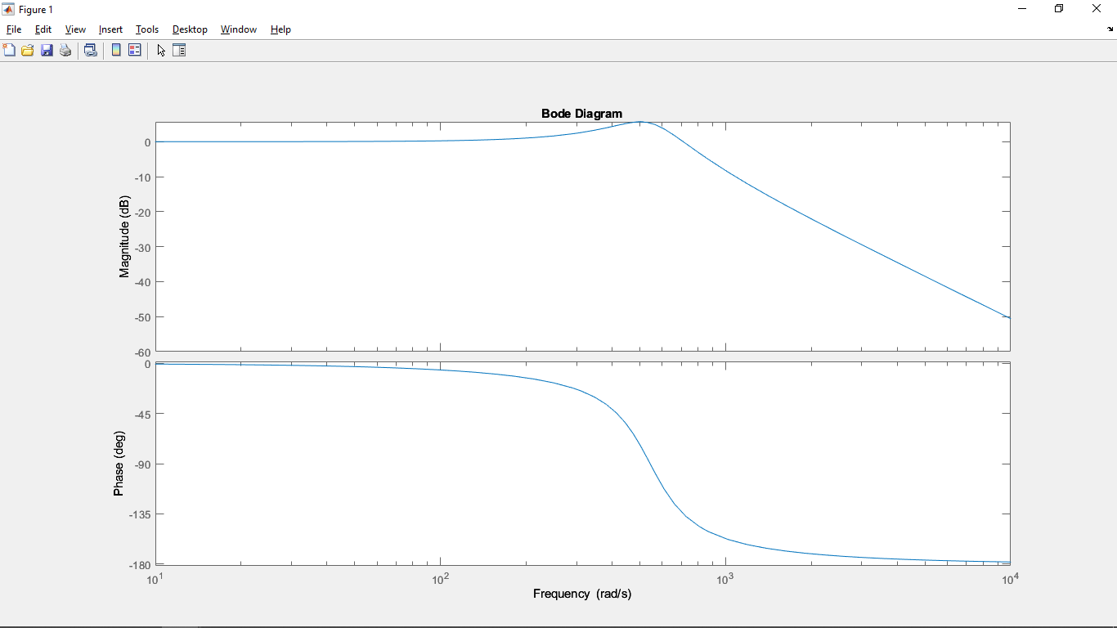Bode Plot :

*Fig 19. Bode plot for the given transfer function*

Nyquist Plot:

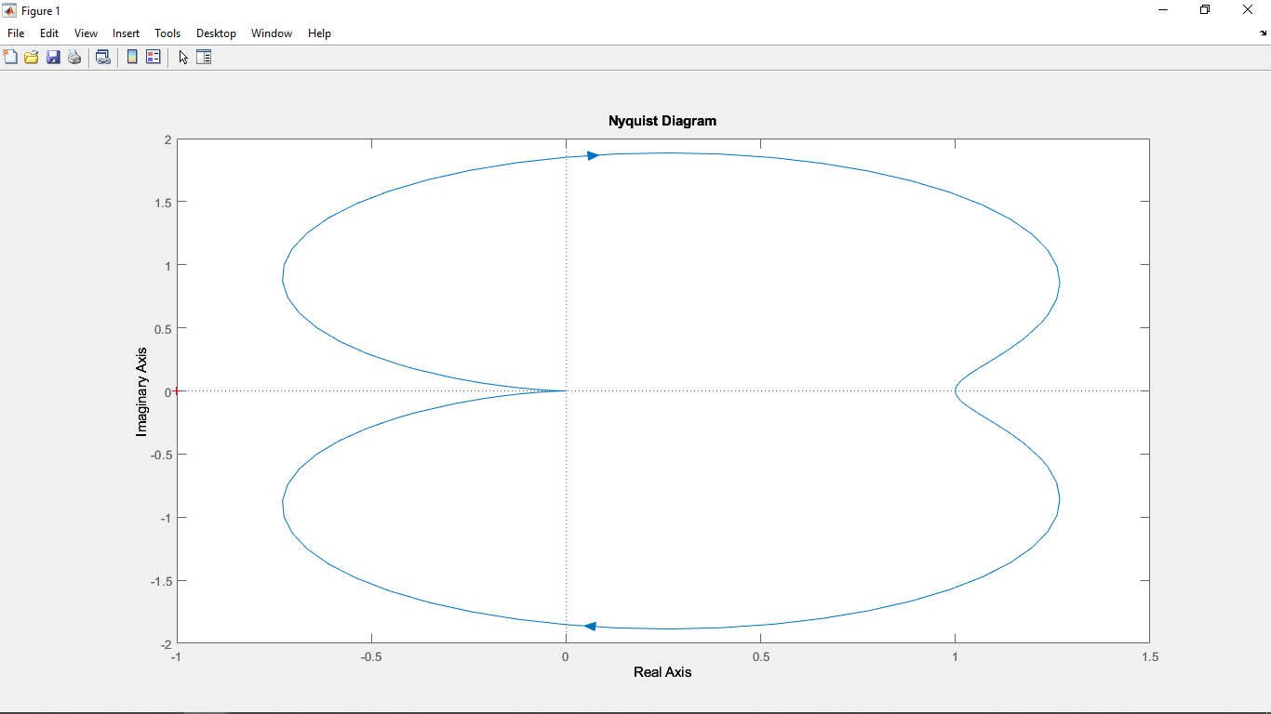

*Fig 20. Nyquist plot for the given transfer function*

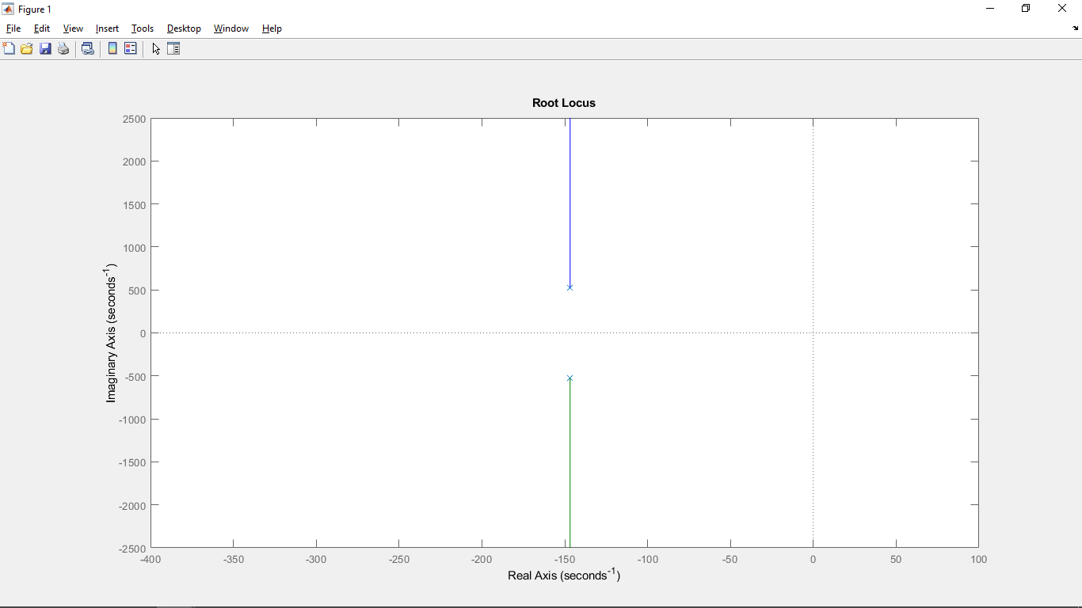Root Locus:

*Fig 21. Root locus plot for the given transfer function*

Upon examining the root locus plot, it becomes apparent that there are two poles situated on the left-hand side. This indicates that they are absolutely stable. By analyzing the Bode plot, both the phase and magnitude graphs, we can infer that the system possesses an infinite gain margin. This implies that regardless of how much the gain is increased, the system will remain stable. Additionally, from the Nyquist plot analysis, we can confidently ascertain that the system is stable. Collectively, these observations confirm the stability of the system under consideration.

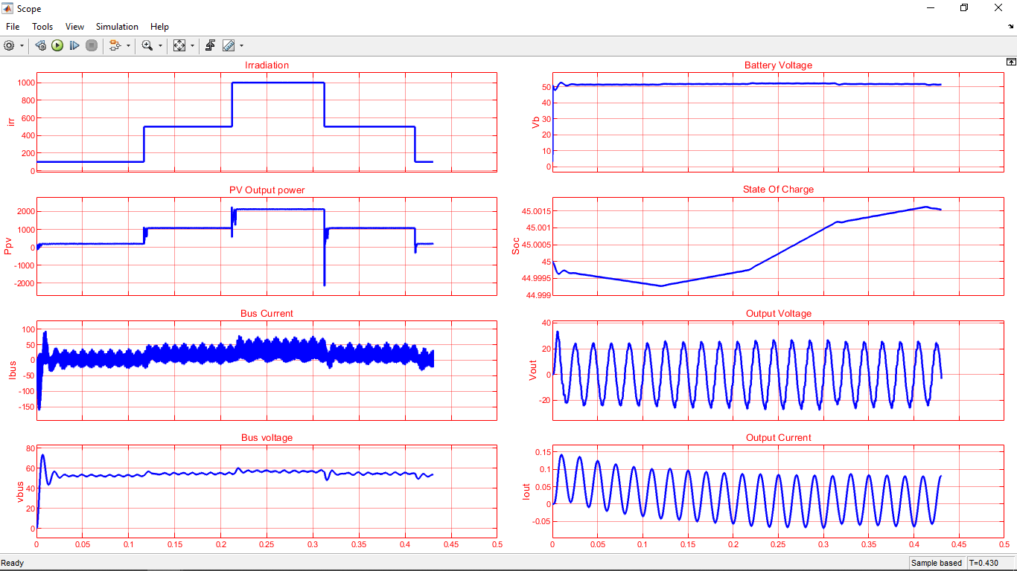Based on our earlier determination of system stability, we now turn our attention to observing the system's behavior relative to varying irradiation levels. In cases of low irradiation, the system relies on the battery to supply the required power. Conversely, when irradiation levels are high, the excess power charges the battery while also being directly delivered to the load. This dynamic behavior ensures optimal power management and utilization.

*Fig.22 System Behavior for different irradiance*

To gain insight into the system's performance, we examine the current and voltage graphs depicted in the figure. Notably, these graphs reveal the impact of the LC filter on the system's output. The LC filter effectively smooths the output waveform, resulting in a sinusoidal shape characterized by a fundamental frequency of 50 Hz. This demonstrates the system's ability to maintain a stable and consistent power supply at the desired frequency.

By incorporating the LC filter, the system mitigates potential harmonics and unwanted frequency components, enhancing the overall quality and reliability of the delivered power. This filtering process plays a crucial role in ensuring that the system operates within acceptable limits and adheres to regulatory standards.

Chapter 6

Conclusions and Future Works

During the course of this project, we conducted an in-depth study and implementation of a solar-based microgrid using MATLAB. By deriving a transfer function and analyzing the results through various plots, we gained valuable insights into the system's behavior. However, it is important to note that despite successful simulations, certain challenges remain within the system. One prominent issue is the high initial cost associated with setting up the solar microgrid. While the maintenance costs are relatively low. Additionally, we observed frequency and voltage drops in the system when there were sudden changes in irradiation. Although abrupt fluctuations in irradiation are unlikely, the occurrence of such drops reveals a vulnerability in the system's stability. Addressing this issue would involve developing appropriate control mechanisms and incorporating energy storage solutions to ensure a consistent and reliable power supply.

As we conclude this project, our future plans involve taking the lessons learned and applying them to a practical implementation in a small area. By comparing the theoretical results obtained from simulations with the practical observations, we aim to gain a better understanding of the differences and challenges that may arise in real-world scenarios. This practical implementation will provide valuable insights into the performance, efficiency, and adaptability of the solar microgrid system in a real-world environment.

Bibliography

"Photovoltaic Systems Engineering" by Roger Messenger and Jerry Ventre

"Power Electronics and Renewable Energy Systems: Proceedings of ICPERES 2014" edited by A. K. S. Bhat, Anupam Shukla, et al.

"Renewable and Efficient Electric Power Systems" by Gilbert M. Masters

"Grid Integration of Wind Energy Conversion Systems" by Siegfried Heier

"Power Electronics: Converters, Applications, and Design" by Ned Mohan, Tore M. Undeland, and William P. Robbins

Aditi & A.K.Pandey, “Performance Analysis of grid connected PV Wind Hybrid Power system,” International Journal of Applied Engineering Research, vol 11,no.1, pp.706-712,(2016).

Modeling and Control of Utility Grid Connected Solar Photovoltaic Array Integrated System Using MATLAB by MAJHRUL ISRAR,ASHOK KUMAR PANDEY ©2017 IEEE

Research on model management method for Micro-grid by CHEN Hong, LENG Hua, TANG Haiguo, ZHU Jiran, GONG Hanyang State Grid Hunan Electric Power Corporation Research Institute Changsha, China and ZHONG Huabing Beijing Tianshi New Energy Technologies CO, Ltd Beijing, China